FORMATTING INSTRUCTIONS FOR DRAFT PAPERS
(TIMES NEW ROMAN, BOLD, 14)
(14-point blank line)
Abstract. The purpose of these instructions is to serve as a guide for formatting the extended abstracts to be published in the ebook of the III Gaúcho Symposium on Aerospace and Mechanical Engineering, SEAM2024. The abstract should describe the objectives, methodology, and main conclusions of the work. It should not contain equations or bibliographic references. (Times New Roman, italic, 10)
(10-point blank line)
Keywords: Keyword 1. Keyword 2. Keyword 3 ... (up to 5 words) (Times New Roman, italic, 10)

1. INTRODUCTION (Times New Roman, Bold, 10)
(10-point blank line)
The draft papers must be formatted strictly according to these instructions. This file can be adopted as a template for Microsoft Word users. This document should also be used as a formatting guide for users of other word processing software. The extended abstracts should have the following sections: title, abstract, keywords, introduction, materials and methods, results and discussion, conclusions, and references. The file should be submitted in .pdf format.
(10-point blank line)
2. TEXT’S FORMAT
(10-point blank line)
The text should be written in english on A4 size pages, using Times New Roman font, size 10, except for the title, author identification, affiliation, abstract, and keywords, which should follow the formatting indicated above. Pages should have a 2 cm margin. Text blocks containing the title, author identification, affiliation, abstract, and keywords should be written in a single column, while the other sections of the work should be written in double columns. The text should be justified, with the first line of each paragraph indented by 0.5 cm. Footnotes should not be used. Symbols and notations should be described in the text, and physical quantities should be expressed in the International System of Units. Mathematical symbols should be typed in italics. Bibliographic references should be cited in the text by the authors' last names and the year of publication, according to the following examples: "Recent works (MCCONNELL; VAROTO, 2013)..." or "Recently, McConnell and Varoto (2013)..." In the case of three or more authors, the form "Rodriguez et al. (2006)" should be used.
References with the same authors and publication years should be differentiated by the indices "a", "b", etc. after

the publication year. For example: "Trindade and Benjeddou (2011a)..." Acceptable references include articles published in technical and scientific journals, dissertations, theses, articles published in conference proceedings, books, and book chapters. Internet pages should be avoided. References should be listed at the end of the work, following the instructions indicated in Section 3.
(10-point blank line)
2.1. Section’s titles and subtitles
(10-point blank line)
Section titles and subtitles should be left-aligned and typed in Times New Roman font, size 10, in bold. They should be numbered using Arabic numerals separated by periods. No more than 2 sub-levels should be used, and a blank line should be inserted above and below each title/subtitle.
(10-point blank line)
2.2. Equations
(10-point blank line)
Equations should be indented by 0.5 cm from the left margin. They should be written in Times New Roman font, italicized, size 10. Arabic numerals in parentheses and aligned to the right should be used for equation identification. In the text, equations should be referenced as "Eq. (1)" within the sentence and as "Equation (1)" at the beginning of the sentence. Symbols used in equations should be defined immediately before or after their first appearance. A blank line should be inserted above and below each equation.
(10-point blank line)
$y=ax+b$ (1)
(10-point blank line)
2.3. Figures and tables
(10-point blank line)
Figures and tables should be positioned as close as possible to their first citation and should be sequentially identified with Arabic numerals. Figures and Tables should be referenced as "Fig. 1" and "Tab. 1" within the sentence and as "Figure 1" and "Table 1" at the beginning of the sentence. Figures, tables, and their captions should be centered on the page. Captions, typed in Times New Roman size 10, should not exceed 2 lines. A blank line should be inserted above and below each figure or table. (10-point blank line)
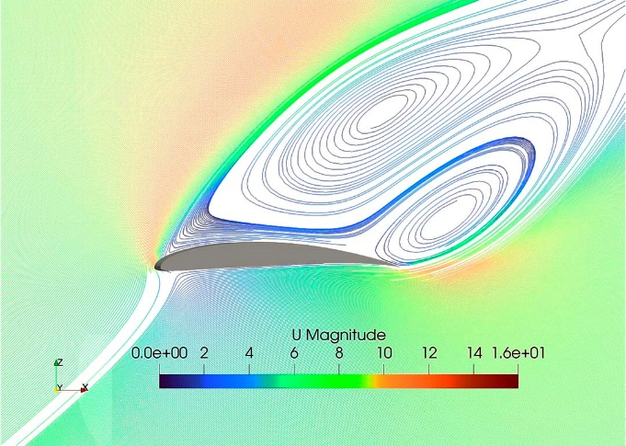
(10-point blank line)
Figure 1. Distribution of normal stresses during the rectification of a straight and helical channel
(10-point blank line)
The style of table borders is flexible.
(10-point blank line)
Table 1. Viscosity and thermo-physical properties of a mineral oil compared to water
(10-point blank line)
Physical Quantity | Oil | Water
Heat Capacity [J/g.K] | 1,9 | 4,2
Thermal Conductivity [W/m.K] | 0,13 | 0,6
Heat of Vaporization [J/g] | 210 | 2260
Viscosity at 40°C [mm²/s] | 5-20 | 0,66
(10-point blank line)
3. REFERENCES
(10-point blank line)
The reference list should be introduced as a new section, located at the end of the article. The first line of each reference should be left-aligned, and subsequent lines should have a 0.5 cm hanging indent from the left margin. All references included in this section must have been cited in the text. References should be organized in alphabetical order by the last name of the first author, following the formatting recommended by the Manual de Dissertações e Teses da UFSM – MDT (https://repositorio.ufsm.br/handle/1/24203). Below are some examples, in this order, of reference typologies: book chapter, book, scientific article, article in conference proceedings, thesis, and dissertation.

BRUNATTO, Silvio Francisco et al. Martensitic Stainless Steel: Direct Current Low-Temperature Plasma Carburizing. In: COLÁS, Rafael; TOTTEN, George E. (Org.). Encyclopedia of Iron, Steel, and Their Alloys. New York: CRC Press: Taylor & Francis, v. 1-5, p. 2153-2168, 2016. Doi: 10.1081/E-EISA-120051667.
SCHEUER, Cristiano José et al. Sequential low-temperature plasma-assisted thermochemical treatments of the AISI 420 martensitic stainless steel. Surface and Coatings Technology, v. 421, p. 127459, 2021. Doi: 10.1016/j.surfcoat.2021.127459.
SCHEUER, Cristiano José et al. Caracterização das propriedades nanomecânicas do aço inoxidável martensítico AISI 420 cementado por plasma a baixa temperatura. In Anais do 11º Congresso Brasileiro de Engenharia de Fabricação – COBEF 2021. Curitiba-PR, Brasil. Doi: 10.26678/ABCM.COBEF2021.COB21-0133
SCHEUER, Cristiano José. Comportamento tribológico e resistência à corrosão do aço inoxidável martensítico AISI 420 cementado por plasma a baixa temperatura. 2015. Tese. (Doutorado em Engenharia Mecânica), Universidade Federal do Paraná, Curitiba, PR, 2015. Disponível em: https://acervodigital.ufpr.br/handle/1884/40502.

